Use Case Diagram

This proposed software system is to be designed to allow passengers to check in and get the boarding pass for flying. The baggage can also be checked-in, which is optional. The check-in can happen by the counter clerk or by the passenger using kiosk.

The system should allow individuals as well as group of passengers to check-in through the system. The boarding pass can be issued through this system. Passengers below 4 yrs need not have tickets. The airport also allows to provision for the special needs of passengers like wheelchair etc.  
The system should also be able to capture the fact that the baggage for a passenger is screened by security.

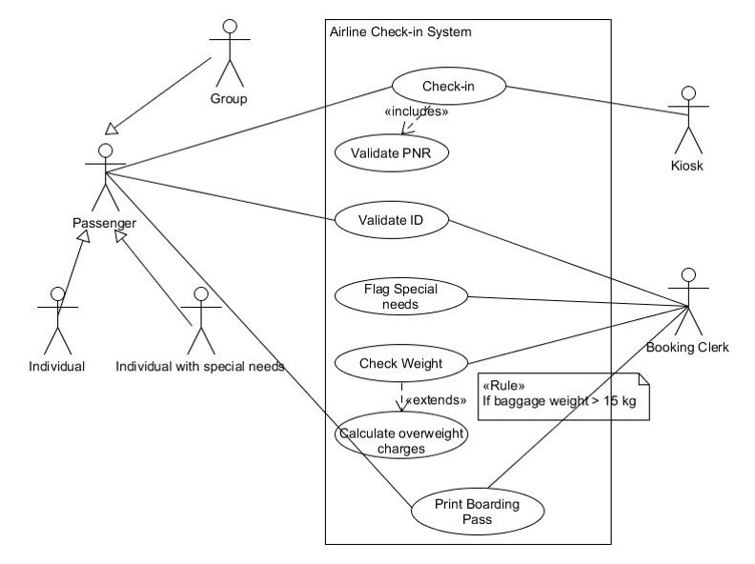

Let us consider a simple business scenario in a restaurant. A customer walks-in to the restaurant to have food. The waiter approaches the customer to take the order and the customer places an order for the food of his choice. The waiter confirms the order and passes it on to the chef, who prepares the food for the customer. Once the food is ready, the waiter serves the food to the customer. The customer enjoys his food and makes a payment to the cashier with the help of the waiter.

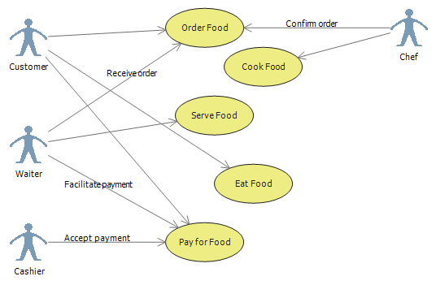

**ONLINE SHOPPING CART**

**Web Customer** [**actor**](https://www.uml-diagrams.org/use-case-actor.html) uses some web site to make purchases online. Top level [**use cases**](https://www.uml-diagrams.org/use-case.html) are **View Items**, **Make Purchase** and **Client Register**. View Items use case could be used by customer as top level use case if customer only wants to find and see some products. This use case could also be used as a part of Make Purchase use case. Client Register use case allows customer to register on the web site, for example to get some coupons or be invited to private sales. Note, that **Checkout** use case is [**included use case**](https://www.uml-diagrams.org/use-case-include.html) not available by itself - checkout is part of making purchase.

Except for the **Web Customer** actor there are several other actors which will be described below with detailed use cases.

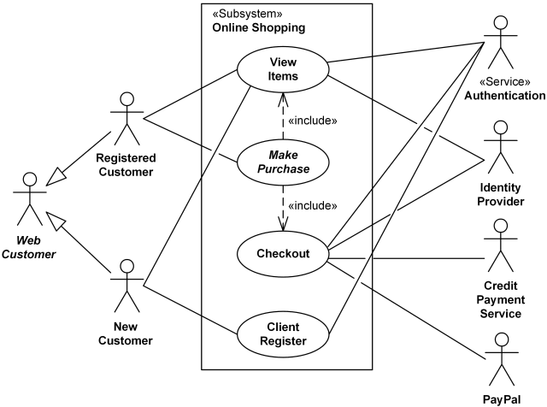

**View Items** use case is [**extended**](https://www.uml-diagrams.org/use-case-extend.html) by several optional use cases - customer may search for items, browse catalog, view items recommended for him/her, add items to shopping cart or wish list. All these use cases are extending use cases because they provide some optional functions allowing customer to find item.

**Customer Authentication** use case is [**included**](https://www.uml-diagrams.org/use-case-include.html) in **View Recommended Items** and **Add to Wish List** because both require the customer to be authenticated. At the same time, item could be added to the shopping cart without user authentication.

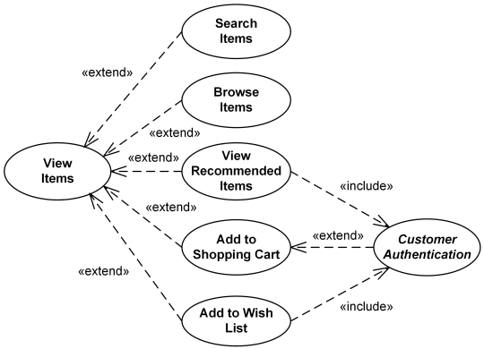

**Checkout** use case includes several required uses cases. Web customer should be authenticated. It could be done through user login page, user authentication cookie ("Remember me") or Single Sign-On (SSO). Web site authentication service is used in all these use cases, while SSO also requires participation of external identity provider.

**Checkout** use case also includes **Payment** use case which could be done either by using credit card and external credit payment service or with PayPal.

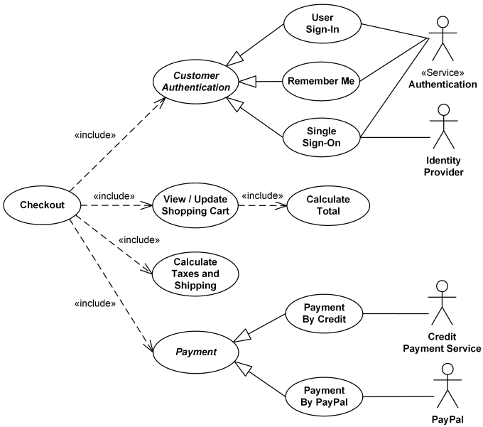

### Book publishing use case diagram example

This use case diagram is a visual representation of the prose scenario shown above. Whether you’re an author, an agent, or a bookseller, inserting this diagram into your use case scenario can help your team publish the next big hit.  A book publishing use case diagram is here.

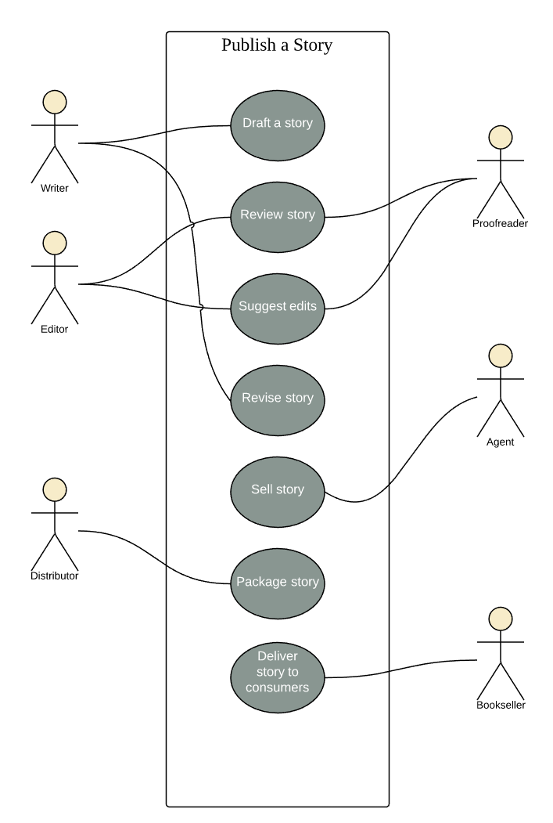

CLASS DIAGRAM

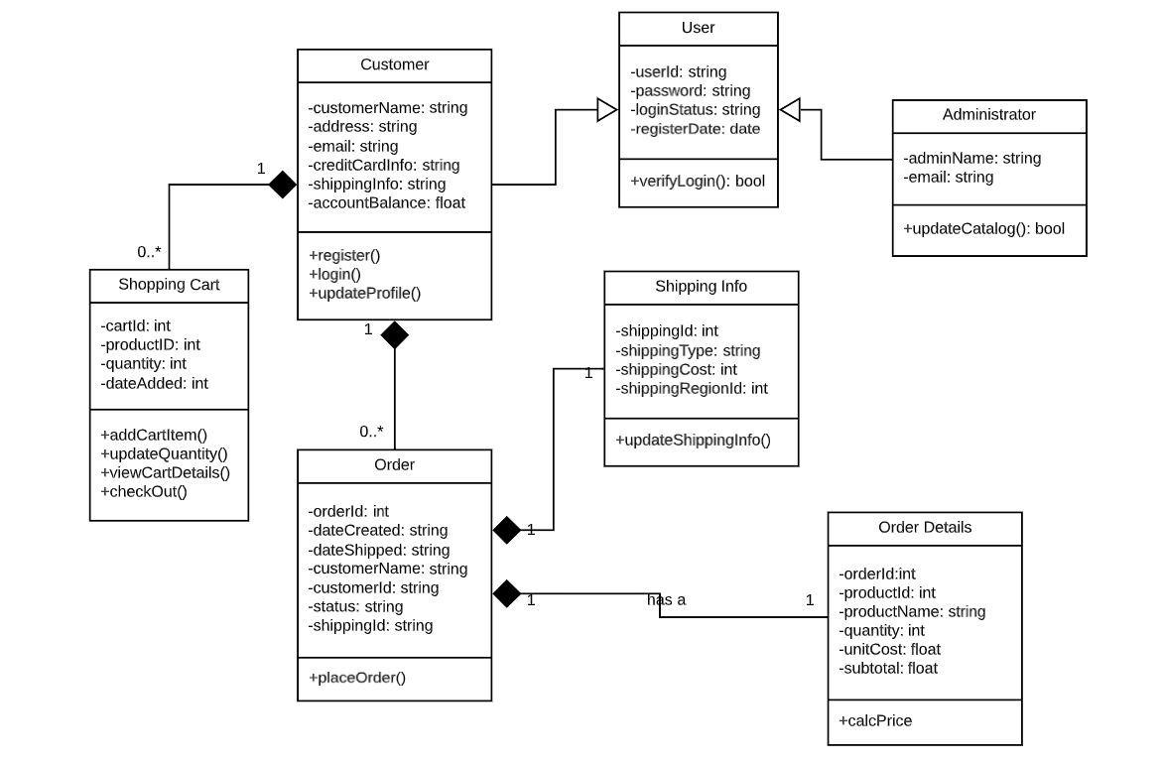

**ACTIVITY DIAGRAM**



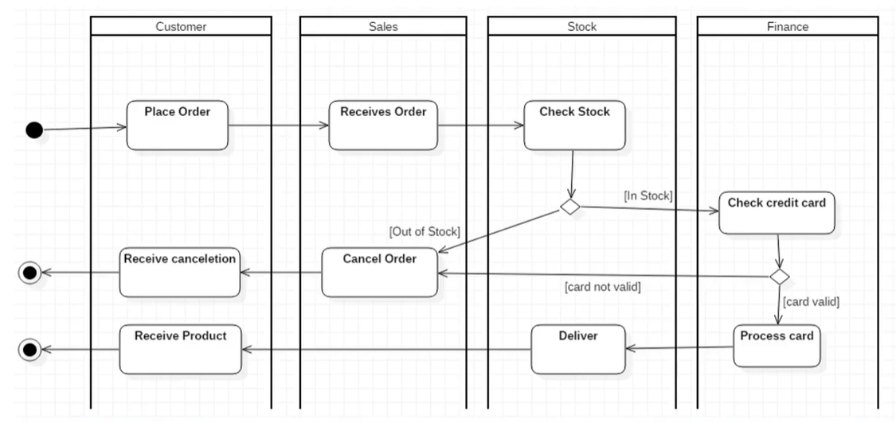

Activity Diagram - Modeling a Word Processor

The activity diagram example below describes the workflow for a word process to create a document through the following steps:

* Open the word processing package.
* Create a file.
* Save the file under a unique name within its directory.
* Type the document.
* If graphics are necessary, open the graphics package, create the graphics, and paste the graphics into the document.
* If a spreadsheet is necessary, open the spreadsheet package, create the spreadsheet, and paste the spreadsheet into the document.
* Save the file.
* Print a hard copy of the document.
* Exit the word processing package.

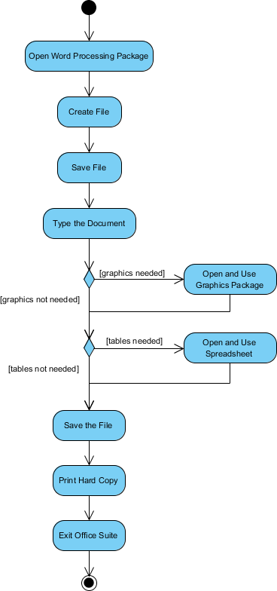

Activity Diagram Example - Process Order

Given the problem description related to the workflow for processing an order, let's model the description in visual representation using an activity diagram:

|  |
| --- |
| Process Order - Problem Description   * Once the order is received, the activities split into two parallel sets of activities. One side fills and sends the order while the other handles the billing. * On the Fill Order side, the method of delivery is decided conditionally. * Depending on the condition either the Overnight Delivery activity or the Regular Delivery activity is performed. * Finally the parallel activities combine to close the order. |

The activity diagram example below visualize the flow in graphical form.

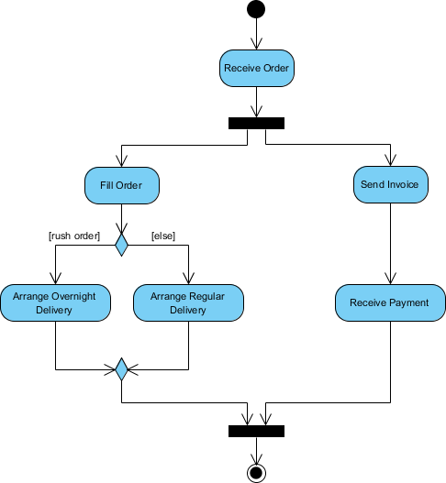

Activity Diagram Example - Student Enrollment

This UML activity diagram example describes a process for student enrollment in a university as follows:

* An applicant wants to enroll in the university.
* The applicant hands a filled out copy of Enrollment Form.
* The registrar inspects the forms.
* The registrar determines that the forms have been filled out properly.
* The registrar informs student to attend in university overview presentation.
* The registrar helps the student to enroll in seminars
* The registrar asks the student to pay for the initial tuition.

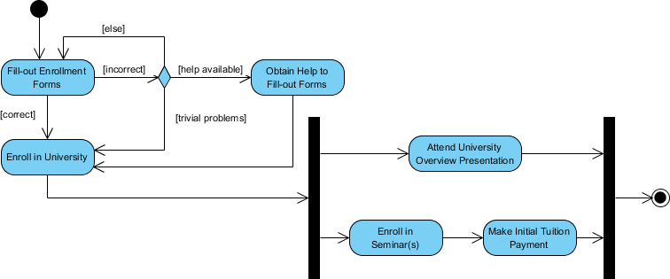

SWIMLANE Diagrams

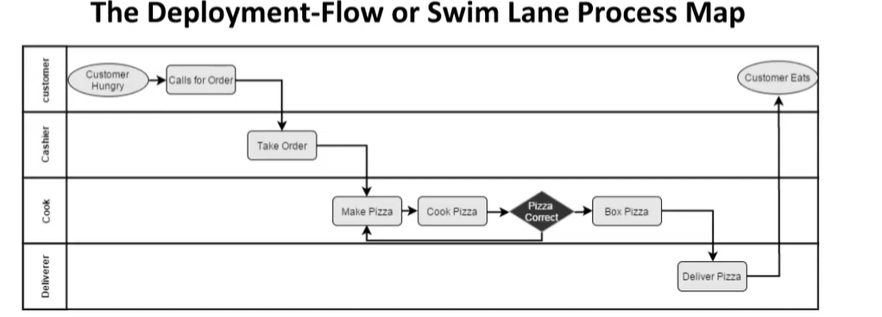

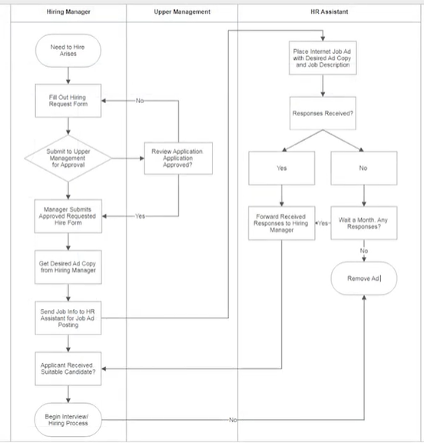

Swimlane and Non-Swimlane Activity Diagram

The activity diagram example below describes the business process for meeting a new client using an activity Diagram without Swimlane.

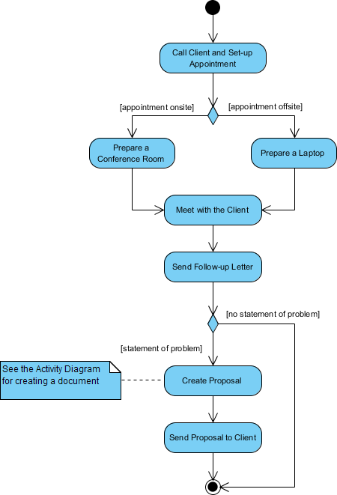

This figure below describes the business process for meeting a new client using an activity Diagram with Swimlane.

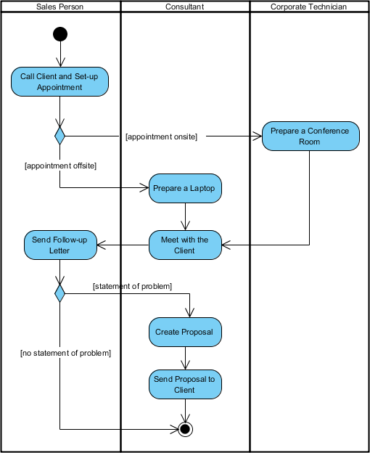

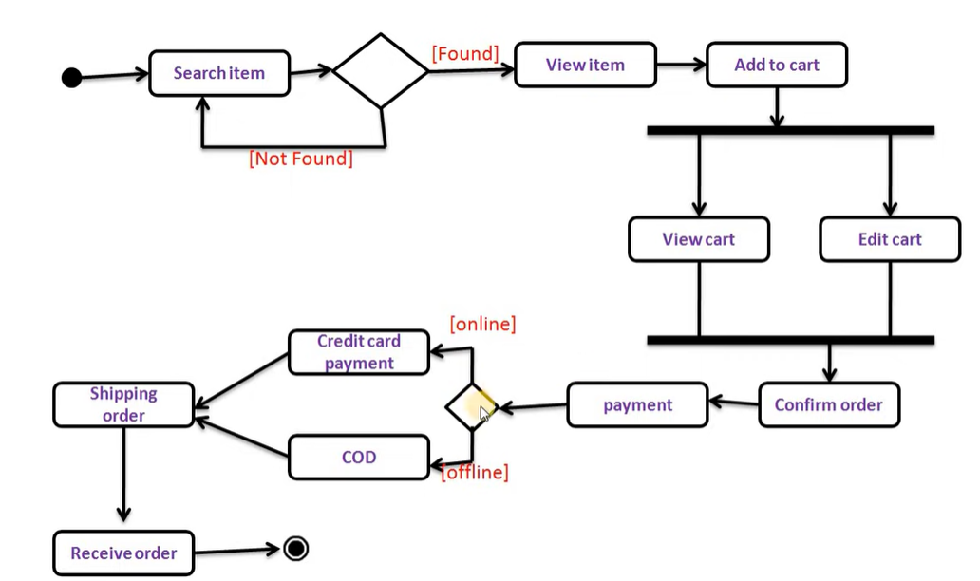

STATE Diagram

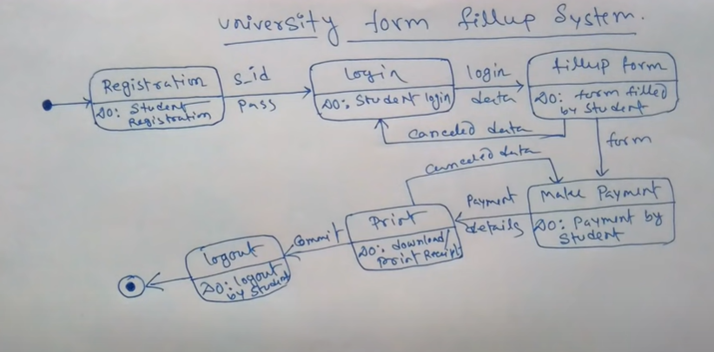

DEPLOYMENT Diagram

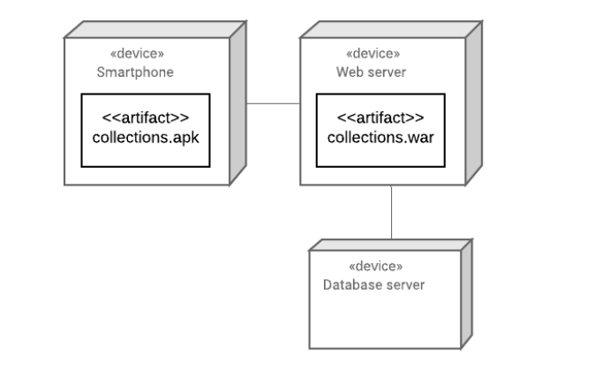

The example below illustrates the infrastructure required for the deployment of a software system for a museum;

• The infrastructure can be described as composed by three different hardware elements: the server named Web Server, the sever named Database Server and Smartphones of the end-users;

The installation of the system in this infrastructure comprises two files:

• collections.apk is a file that is installed on smartphones and that provides an app to allow accessing a museum’s online catalog;

• collections.war is a file to be installed on the server named Web Server and that will provide data to the

smartphone app.

2. Consider a software system to monitor the temperature in the exhibition room of a museum. Temperature data is obtained through a sensor attached to a small computer (RaspberryPi) where it is installed a service responsible for reading data from the sensor and sending it to a central server. This service consists of a single file temperatureCollector.jar. In the central server, data is aggregated and stored in a database. This task is performed by a piece of software packaged in the file dataAggregator.jar. The aggregated data is used by another service that computes some temperature statistics. This is a Web application and is installed in a dedicated Web server as the file statistics.jar. How would you design the deployment diagram for such a software system?

